
QUICK REFERENCE GUIDE
Avenza iPAD
For Rehab

Oneline instruction can be found at
http://help.avenza.com/customer/en/portal/articles/2570221-product-documentation
iOS
http://help.avenzamaps.com/customer/en/portal/topics/950368-avenza-maps-for-ios/articles
Android
http://help.avenzamaps.com/customer/en/portal/topics/951155-avenza-maps-for-android/articles

Most of the data and instruction in the document was copied from Avenza website, links provided above.

Purpose – For Wildfire Rehab
Currently, Field Data collection is done using Avenza. Avenza allows for a Rehab Specialist to:
- Import any PDF Map made by the GIS Specialist, the larger the map showing a small area (Large scale) would be best when using Avenza. Note: A 11x17 PDF Map may not be of much use in Avenza unless it’s showing a very small area. A 1:5,000 Scale is best. 1:30,000 would not be of much use for field data collection but would work well for navigation.
- As long as the map is imported into Avenza before heading out into the field, this app can be used without internet or cell coverage
- User Location will show up as a blue dot on the map
- It allows the user to collect field data by creating a KML that includes:
  - drop points to your location or where the user directs the point to be placed and assign attributes and a photo;
  - create a line by using the measure tool, and add descriptive text and
  - create a line by tracking your movements and add descriptive text
- Export the data collected via E-mail as a KML to the GIS Specialist or to be used in Google Earth. Internet is required for both.
- Create Schema so that when a point is created a drop down list can be used for the rehab Treatment Type. This Schema (with points or lines) can be exported and e-mailed to others to be used. This will reduce errors and speed up data collection.

Pro License
GeoBC has a corporate License that allows for full functionality of Avenza. Avenza is best used on an iPad or Android with an operating system of 6.0 or newer. Earlier versions may have a minor shift in the data when exported.
BC Government employees can acquire Avenza Pro License by contacting NRS.Maps@gov.bc.ca.

Creating a Point
Two ways to add a point:
- Current Location (Using Tracking)
- Manually
Tap here in the bottom left to locate your location. When this turn blue , the app is now tracking your location. You will see a blue dot showing your location.

Adding a Point – Using Tracking/ Current Location
There is a GPS accuracy associated 8m-40m. To drop a point at this blue dot, select the in the bottom left corner of the screen, add descriptive text. To add a Pick List look at the section on Adding attributes to a line using KML Schema

Adding a Point - Manual
This will allow you to add a point in a location where you are not. Move the map so the cross hairs on the screen fall in the location where you want to drop a Pin. Select the , add descriptive text. It is highly suggested that if the field work allows the use of a Pick List for data collection to reduces confusion when data is submitted. See Section on KML Schema for instructions

Creating a Line
Two ways to add a line:
- Current Location (Using Tracking)
- Manually
Tap here in the bottom left to locate your location. When this turn blue , the app is now tracking your location. You will see a blue dot showing your location.

Adding a Line – Current Location (Tracking)
On the bottom right corner of the screen select , Record GPS Tracks – START (Bottom left corner of screen). Travel the legth of the line you would like to collect. There should be one data location collected (Node) in one second intervals. Once you are finished collecting the track hit STOP (Bottom left corner of screen).
To add description/attributes, Select the line, hit the . This will allow you to add description text or select from a KML schema that was imported or created.
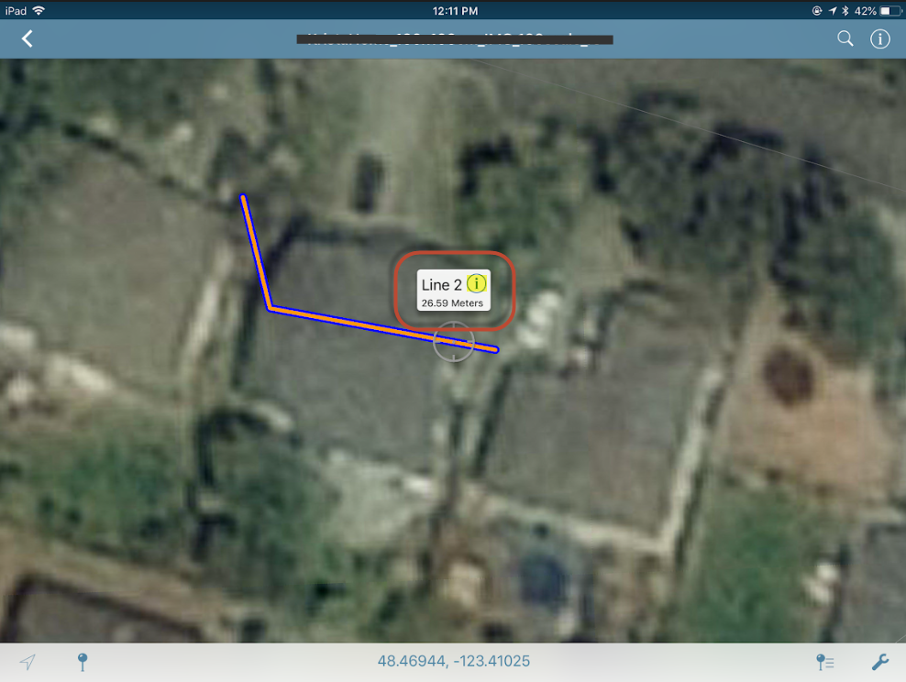

Adding a Line - Manually

Accessing the Draw and Measure Tool
- Open the desired map that you want to draw/measure lines or areas on
- Tap the Tools icon (wrench in the lower right-hand corner), then tap 'Draw and Measure'
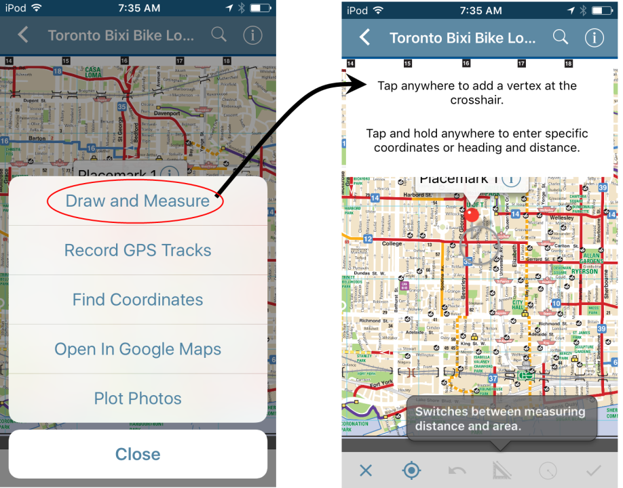

- With the Draw and Measure tool open, pan around the map until the crosshair is centered where you like to create your first point
- Once the crosshair is in place, tap anywhere on the map view to create the first vertex
- Continue in this fashion until your line is complete. If you need to undo a point you just made, tap the back arrow on the toolbar to remove the last vertex
- While drawing, you will see the line measurements at the top of the screen for the current segment, and a total of all lines
- Once satisfied with your line, tap the checkmark on the lower right-hand side to save the line. It will now be listed in your Map Features list
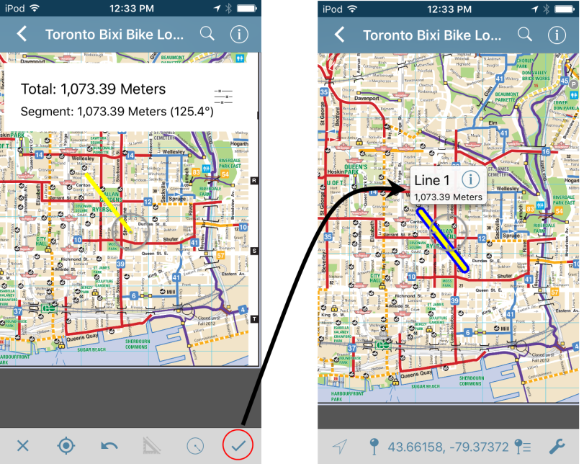
To add description/attributes, Select the line, then hit the . This will allow you to add description text or select from a KML schema (picklist) that was imported or created.

KML Schema (Pick List)

KML Schema for Rehab
KML Schema reduces errors and data collection time. It can be up in advance and allows attributes to be selected from a drop down menu (pick list) instead of having to be types in. If you are entering a unique number it will also give you a list of numbers that have been previous used. Creating a KML Schema is highly recommended.

This Current Schema has Rehab points and lines and also Incident line types
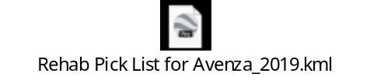

Symbology (export from your e-mail into Avenza)
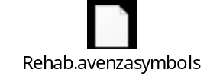
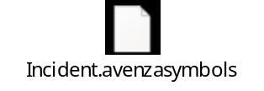
NOTE: When using these in Avenza will not opened in Google Earth Pro some of the points will only have a label and no pin or symbology.

How to edit or create Schema for a KML pick list - Read instructions below or please contact Steve Richards[ Steve.Richards@gov.bc.ca ].

To create an Attribute Schema (Pick List) for a layer:
- Tap Edit from the Layers tab, or from the Map Features list (within the Map View)
- Tap the 'i' icon for the desired layer
- Scroll down to the bottom of the Edit Layer dialog and tap on the '+' icon next to 'Add a New Attribute'. This will open the Edit Attribute dialog
- Rename the attribute as desired (e.g. Tree Type)
- Set the type of attribute
- String - alphanumeric characters
- Boolean - yes or no values
- Real - numbers that can contain decimal values
- Integer - whole numbers
- If desired, set a picklist value
- Tap the '+' icon next to 'Pick List'
- Type in the appropriate value
- Tap the back arrow to return to the Edit Attribute dialog
- Repeat as required
- Tap the back arrow when the attribute is complete
- Repeat steps 3-7 for each desired attribute
Example of attributes to collect for a tree inventory:
- Tree Type > String > Pick List Values: Oak, Pine, Cedar, Maple
- Cut (Y/N) > Boolean
- Circumference > Real
- Lot number > Integer > Pick List Values: 1, 2, 3, 4, 5
NOTE: While attribute schemas can be created outside of the app in other software, it is currently not recommended, as Avenza Maps requires the schema to be in KML format for importing, and often times problems can arise when creating such files in other software packages. If you wish to create your schema outside of Avenza Maps, the best option available is to use a text editor (e.g. Notepad++) with an existing KML schema created from the app as a template.

Adding a Point with KML Schema
- To use this schema when Adding a point.
- Adding a Point Feature - Click on the Pin (Add Placemark)
- Before you hit submit scroll down and select the desired attribute.
- Select the desired attribute.
- If the option you want is not available – select the edit button
- Select the + Add a new Attribute
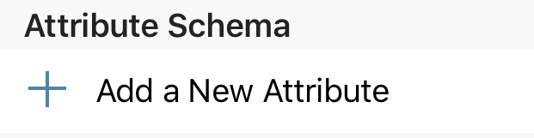
OR add descriptive text.
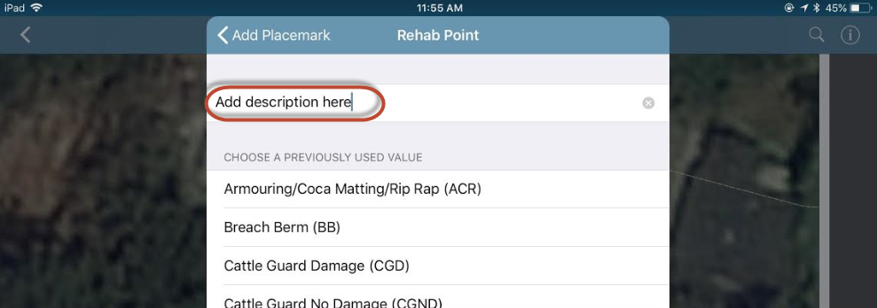

Adding attributes to a Line using KML Schema
Line Features can also be assigned using drop down attributes. The process is a little different. You select the Rehab Line Treatment Type after the line has been created. See below for instructions.
- Once the line has been created,
- select the line (it should have a halo around it to show that its selected),
- click on the button and then in the desired attribute.
- Select the + Add a new Attribute
OR add descriptive text.

Importing KML Schema into Avenza

Importing Attribute Schema into Avenza
To import a custom schema provided to you or that you have created, you will use a similar process to Importing Map Features:
- E-mail yourself the KML above section.
- Open the e-mail and Click on the Box with the arrow pointing up.
- Select Avenza App
- Open the map that you want the schema on
- Tap on the Map Features icon (next to the wrench) (NOTE: you can also import the schema to the Layers tab and choose not to link it to a map. The remaining steps are the same for both options)
- Tap Import Map Features (square with a downward arrow)
- Tap Import Schema
- Navigate to the desired file. Look in the iTunes File Sharing and select Inbox (NOTE: the schema must be in KML format)
- Tap Import then Close.
NOTE: Once imported, the schema will be on its own layer and may require additional changes in order to be the active layer for data collection. Please see below on how to use schemas in the app.
Importing Schema into a Map
With an active layer schema, users can begin collecting data using the pre-designed attributes, icons, any other styling settings. To collect data using a schema please follow the steps below:
- Set the schema as the active layer on a map
  - With the map open click on the
  - Tap the 'i' icon beside the layer from the Map Features list
  - Choose "Set As Active Layer". You will see a check mark appear on the right.
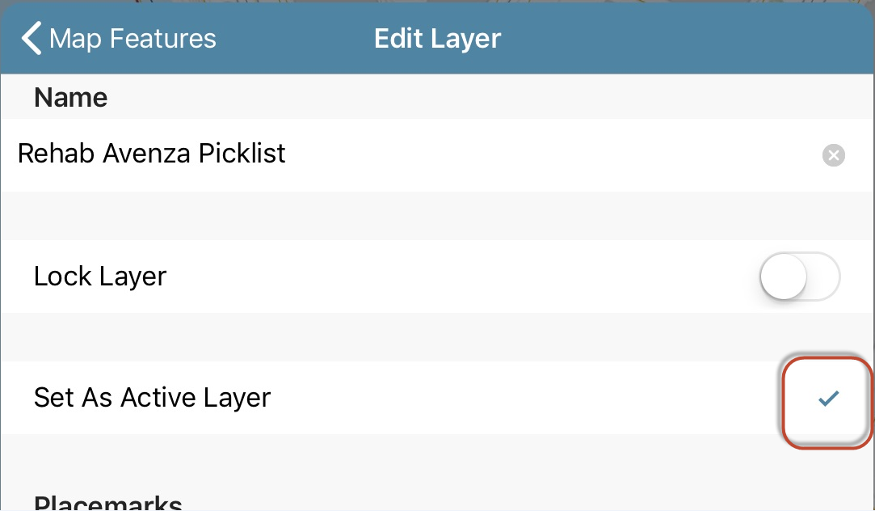
  - Tap Back (top left) and then Close to return to the Map View
- Add a placemark to the map.
- Before confirming the addition of the feature ('Submit' in the top right corner), scroll down to 'Attributes'
- You should see a new list of options that you just imported.
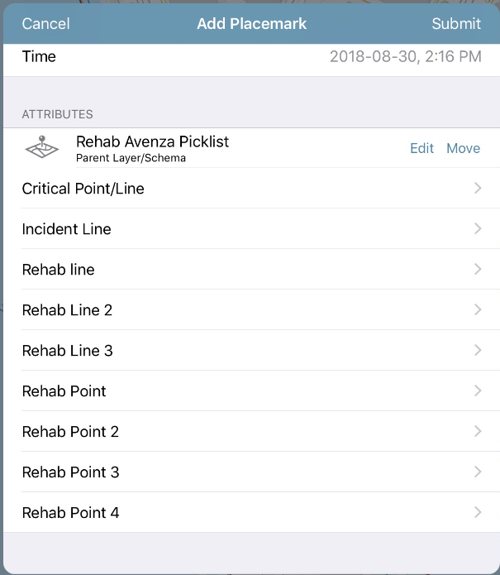

- Rename the KML. Select the then click on the . Re-name the KML. Layerfile with naming Convention i.g. YYYYMMDD_Purpose_Your First and Last name or name of contractor.
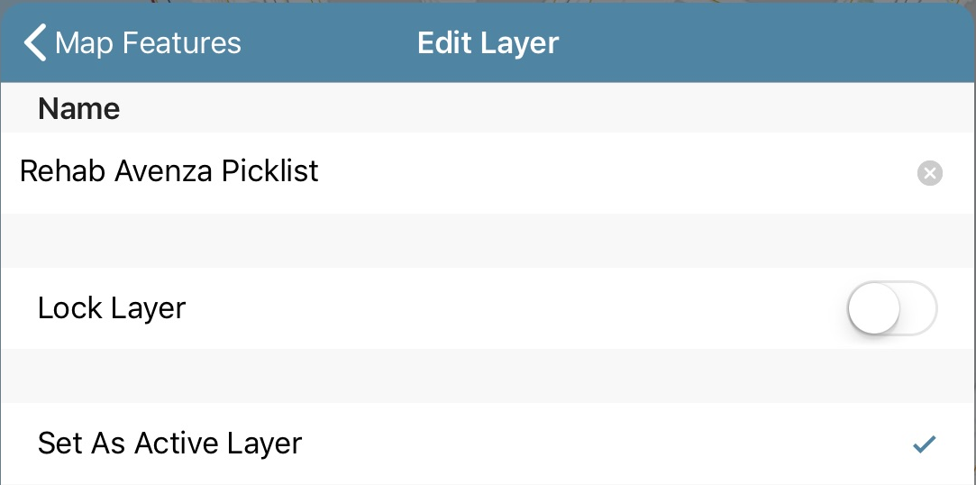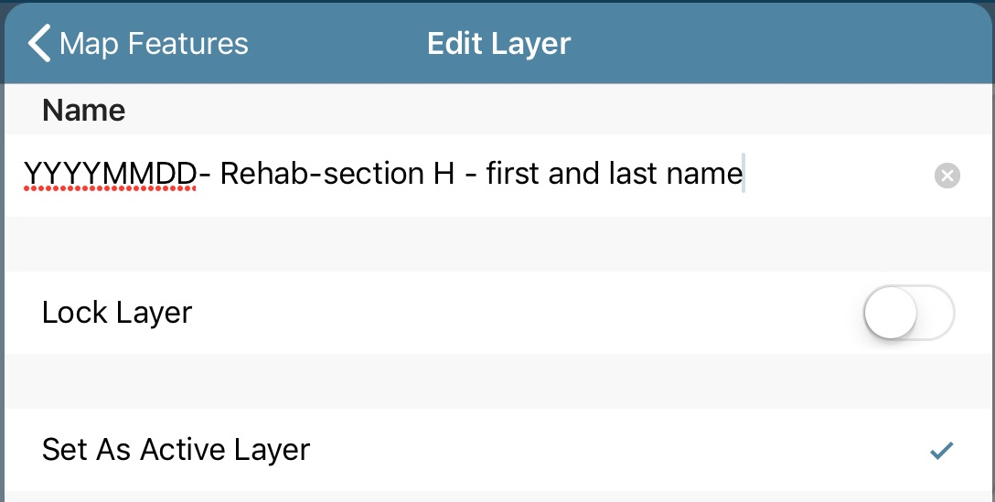
You are ready to collect placemarks or tracks using a picklist to populate the attributes.
- Select the attribute from the list, if what you want is not an option you can either or enter text under the title or add to the pic list.
- Hit Submit.
- If you forgot or wanted to add more info. In the map click on the and add additional info.

Photos

In the Edit Placemark click on the photo graphic, then the “+” to add a new photo. You can either add one from the Library or capture a new photo.
Once you had added/captured a pic you change the name to meet any data submission standards.
Once under the heading Photo - select Edit - select the photo - rename photo.

Rename Photos in Avenza
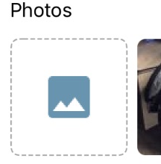
After a photo has been taken, Under the Photos click on the square with the two mountain peaks (see pic to the right), then select the Edit bottom the top Right. Select the photo you want to rename and then use the naming convention below re name the picture. Select Done or the Photo back button.
Naming Convention:
Initial Photo File Name | Final Photo File Name Example
Incident # / Unique identifier / YYYMMDD / Initials of person who took photo | K20637 002 20180707 KN

GIS IMport of Photos in KML
Copy KML and rename file as .ZIP. Extract and there will be an images folder. These photos will not be geo tagged.
When converting KML use Xtools Pro to keep attributes in original KML (including photo names). Using ArcGIS tool KML to Layer will lose all of the attributes.

GIS Import of Photos
Copy KML and rename file as .ZIP. Extract and there will be an images folder. These photos will not be geo tagged.
When converting KML use Xtools Pro to keep attributes in original KML (including photo names). Using ArcGIS tool KML to Layer will lose all of the attributes.

Exporting Data (points and Tracks) from Avenza
In Avenza – open the map with the data you would like to export. Click this button . Select the Rehab KML (Point and Line).
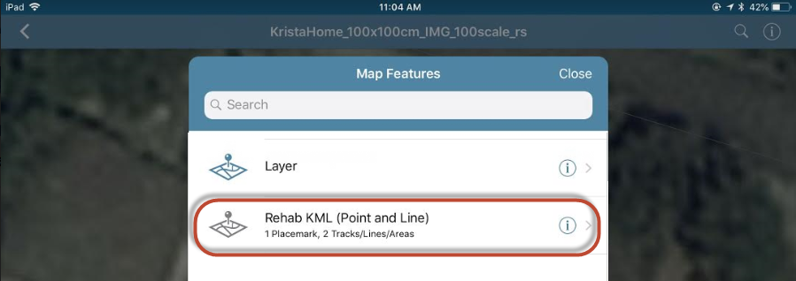
Then to export. On the top right select the Export and select Mail. There are options on what you want to export, make sure you are exporting the data not just the schema. Export format as a KML.
In Avenza, during the export you can rename the KML to follow the naming convention.
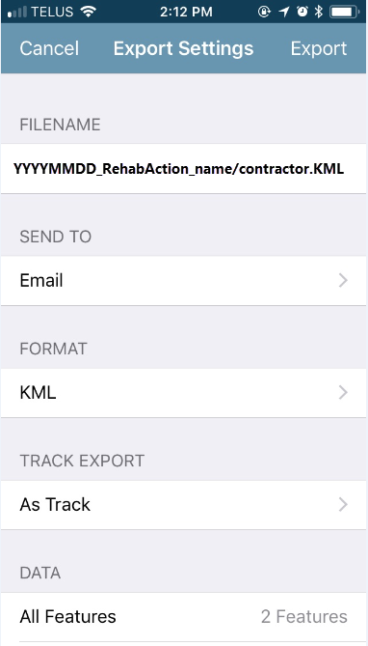

Plot Photos Tool
There are two ways to add a photo.
  - When dropping a Placement add a photo (from your photo Library or take a new photo)
  - Plot Photo’s that you have already taken (that have geotags)
Plot Photos is an alternate way to create a placemark and add the photo. Rather than the traditional method of creating a placemark and then manually adding the photo to it, Plot Photos uses geotagged photos to automatically create a placemark based on the coordinates embedded within the photo. This is ideal if you are taking pictures (ensuring that they are geotagged when you take them - most phones can do this and have it available within the camera settings), and then want to plot them on a map afterward.
To plot a photo:
- Have a valid map open that covers the area required
- Tap the Tools icon (the wrench on the lower right side of the toolbar), then tap Plot Photos.
- On the Photo Browser, select photos, and tap Import.
- A placemark will be added at the location based on the geotagged photo.
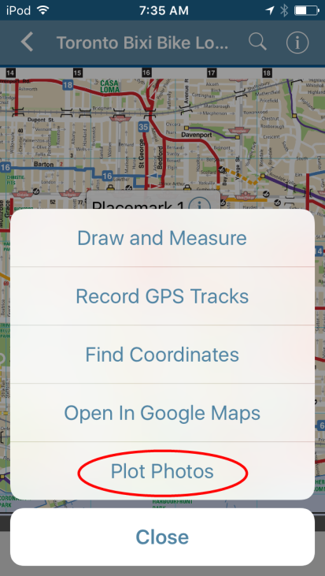
Although only geotagged photos can be added to the map using the Plot Photos tool, you can still add photos from any location to an existing placemark. On an existing placemark, tap the information icon of the placemark label, then tap Photos. Tap the + icon and attach a photo from the Camera or Photo Library. You can attach multiple photos to a placemark. A number at the corner of the photo on the placemark label indicates how many photos are attached. The first photo attached is the one displayed in the placemark label.

Calibrating – iOS (IPAD)

On Apple devices, use the Compass app to calibrate your compass. This app comes pre-installed on iPhone devices. If for any reason it has been deleted, it can be found in the App Store if you search for “Compass”.
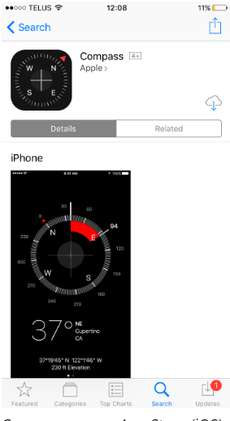
When the calibration screen appears after you open the Compass app, you’ll need to perform a few easy steps to calibrate the compass. Follow the on screen instructions and tilt your phone until the ball moves all the way around the circle. If you are using an earlier iOS, you will be prompted to move your phone in a figure 8 motion.
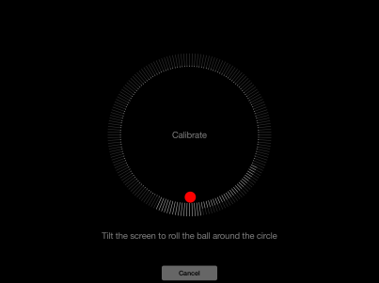
Calibrate device (iOS)
Once this process has been completed, the default compass screen will appear – your compass is calibrated and ready to be used! If the default compass screen appears as soon as the app is opened, your compass is already calibrated. If you see a different page appear on screen, the Compass app also doubles as a leveler; swipe left you will return to the compass screen.
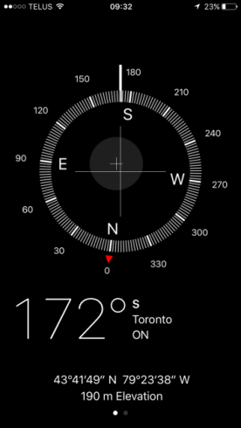
Calibrated device (iOS)

Calibrating - Android
https://www.avenza.com/resources/blog/2017/08/09/calibrating-your-devices-compass-improved-navigation-avenza-maps/
One of the great features of Avenza Maps is being able to navigate offline using your own maps or maps from the Map Store. By tapping the GPS icon twice (once to locate yourself and then again to enable the compass), the map will rotate and align with your compass. Your current location is represented by a blue dot and the little arrow points in the direction you are facing. This feature allows you to navigate easily, however it can be problematic when your devices’ compass isn’t calibrated. If you notice that your blue dot’s arrow is not pointing in the right direction, or isn’t functioning as you’d expect, try these steps to calibrate your device’s compass.
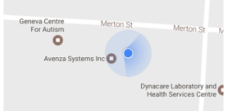
Figure 2: Uncalibrated Device
To calibrate your compass on Android, go to your Google Maps app. If your blue dot’s beam (the blue shading coming out of it) is pointing in a different direction to where you are facing or is very wide, your compass will need to be calibrated. To calibrate, tap the blue dot and select “calibrate blue dot compass”. From here, you will be instructed to move and tilt your device in a figure 8 pattern, shown in the following diagram.
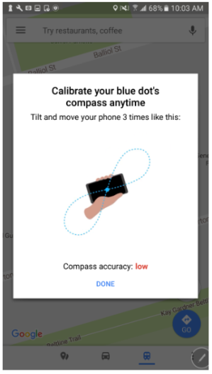
Your compass accuracy will improve as you continue to do this. When you are happy with your compass accuracy, tap Done. The beam from the blue dot on the display will now be narrower and point in the right direction. If at any point the accuracy lowers again, this process can be repeated. If this does not solve your issues, you can select “report blue dot issues” by pressing the blue dot again. For more information, click here.
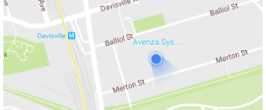
Figure 3: Calibrated Device

Map Folders – Collections (iOS)
http://help.avenzamaps.com/customer/en/portal/articles/2936863-map-folders-vs-collections-ios-

This process will allow you to group maps so it can move from one map to another as you physically move from one to another.

From the My Maps screen, to manage your maps, folders, and collections you will use the 'Edit' button located along the top toolbar.
'Edit' context menu
From the 'Edit' icon, you are able to add a Folder or Collection, as well as move or delete maps in order to better organize your maps.
Folders
A folder allows you to group certain maps together based on your individual needs. The new sorting and filtering options, work within folders, so you can have a mix of maps (Map Store, imported) and be able to sort and filter as you need.
To create a folder:
- Tap Edit
- Tap the Add Folder icon
- Choose Folder
- Tap the 'i' icon
- Name the folder accordingly and select 'Close'
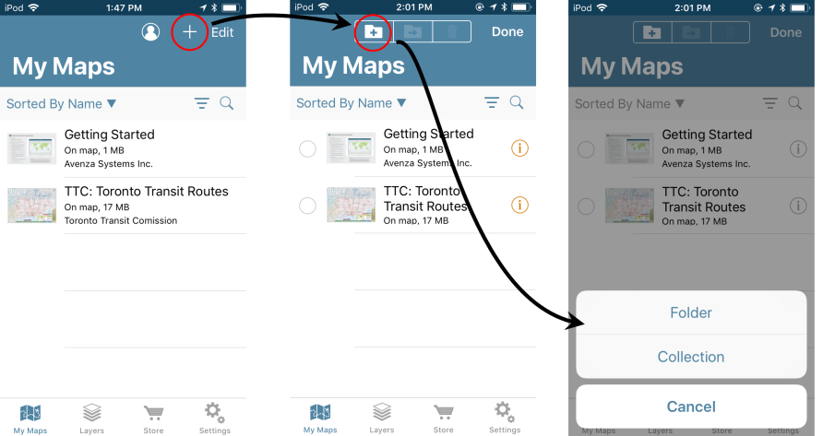
Collections
A collection is similar to a folder in that you can group certain maps together as you choose, however, the key difference is that a collection will allow you to automatically shift from one map to another while in the Map View based on your location/movement, rather than having to open each individual map manually. In addition to switching between maps based on location/movement, you can also pan/zoom between maps*
*The ability to pan/zoom between maps in a collection depends on the maps included, as well as the map scales used. Functionality may vary depending on the maps and scale used.
To create a Collection:
- Tap Edit
- Select the 'Add Folder' icon
- Choose Collection
- Tap the 'i' icon
- Name the folder accordingly and select 'Close'
To turn a Folder into a Collection:
- Tap Edit
- Tap the 'i' icon next to the folder
- Toggle the Collection option on
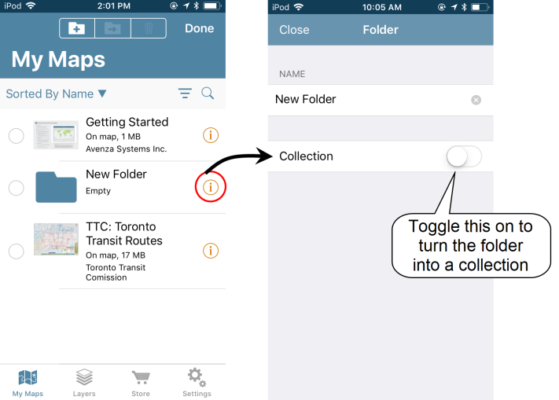
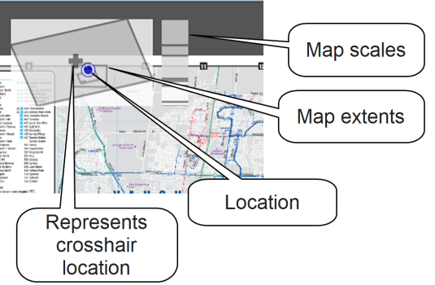
Viewing a map in a Map Collection
When you open a map that is part of a collection, an inset map in the top-left corner shows the extent of all the maps in a Map Collection. On the inset map, a darker gray and a + represents the crosshair and the relative position on the current map. The blue dot represents your GPS location (if applicable). To go to an adjacent map, pan to the edge of the map and continue to pan in the direction of the adjacent map - the adjacent map will automatically load in the map view. This same effect can be achieved by manually moving between map locations.
To jump to any map in the collection, tap a map footprint on the inset map. The vertical column to the right of the inset indicates map scale relative to the other maps in the collection.
To enlarge the inset map, swipe it to the right. To reduce the inset map, swipe it to the left. To hide the inset map, swipe it left until only a tab with arrow shows. To show the inset map, tap the inset map tab or swipe right.
When maps share the similar extent but are of two different map scales, you can pinch to zoom to the larger or smaller scale map by zooming in or out and holding when you reach the maximum or minimum zoom level.

QR Codes
Avenza has a QR code reader built into it. Hit the “Download or import a map” button; when you get to the Add Map screen there’s a list of options, but the header on that screen shows a picture of a QR code – that`s what you press. Then point the camera at the QR code. It seems to be easier in iOS.
On Android device Avenza got the file to download, you have to go back into add the map From Device Storage – Internal Storage – Downloads.

Field Data Submissions - suggestion for contracts
Data Submission Requirements
Data should be submitted in KML format. All identified points and lines should be assigned actions that are planned to be undertaken in the field (or ‘No Treatment’). Fireguards should be captured in one track from start to end when the combination of treatments prescribed is the same along the entire length of the fireguard. Fireguards that have different treatment combinations over their length should be split into segments that reflect each unique treatment combination. Do not include additional data related to travel from one fireguard to another. Do not classify modified roads or heavily used roads as fireguards (even if they served this function during fire control operations). Fireguards with more than one type of treatment should have the spatial data collected only once, and then assigned the specific treatments as prescribed. If no actions are prescribed on a section of fireguard, the section should be identified as ‘No Treatment’ and a comment should be included that specifies the associated rationale. When adding a rehab point, use the KML provided or the options from the Rehab Points, and/or Rehab Lines treatment options. If adding missing incident data, use the correct Incident Line [FLType] classification.
Naming Convention:
The KML should be named with the date, followed by the action planned, the name of the person or client collecting the data, followed by a unique identifier.
For example: <YYYMMDD>_<Rehab Action>_<Name/Contractor Name>.KML
20180808_Seeding_JaneDoe_track1.KML.
Multiple KML’s can also be grouped into one by using Google earth to organize the data.

Example below was taken from Google Earth.
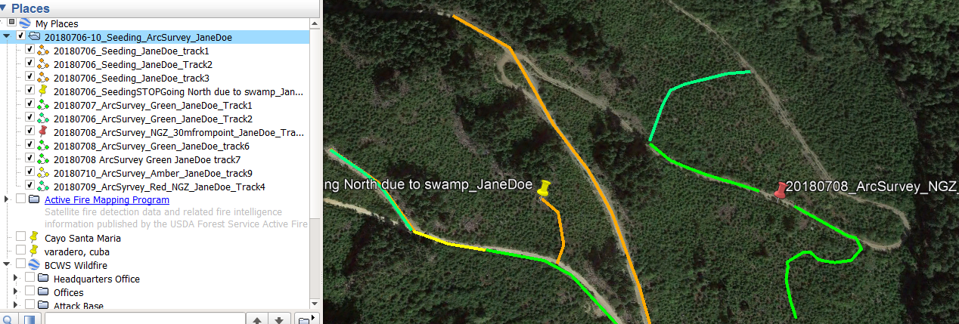
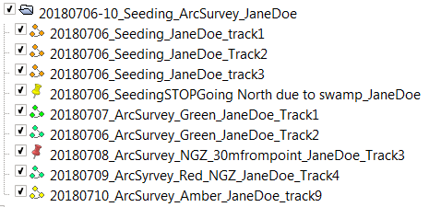
In Avenza, the naming convention can be used in the attribute instead of the name of the KML. Once a track has been saved by clicking on the line, an button will appear on the display and allow for adding an attribute description.

Rename the KML. Select the then click on the . Re-name the KML. Layerfile with naming Convention i.g. YYYYMMDD_Purpose_Your First and Last name or name of contractor.

Document History

When changes are made please update the Guide found below directory:
\\spatialfiles.bcgov\work\!Shared_Access\Provincial_Wildfire_Rehab\Resources\GIS_Standards

Version | Changes Made | Author(s) | Effective Date
1.0 | Started the doc | Krista Northcott | 20180720 -20180828
1.1 | Adjusted for MOF Standards hand-off | Steve Richards | 20220407

